CHAPTER 5

RESULTS AND DISCUSSION
This chapter evaluates the completed Smart Attendance System as an integrated hardware-software platform. The analysis covers the ESP32-S3 classroom controller, OV2640 image capture, buzzer and LED feedback, PCB and enclosure assembly, secure role-based access, automatic session processing, face attendance, responsive interfaces, weighted calculations, and university-style exports. Reported results are based on implemented behavior and repository verification rather than unsupported estimates of recognition accuracy.

5.1. Analysis of the Complete Hardware-Software System
The implementation connects three user roles and two attendance capture modes to one authoritative backend. Administrators configure academic data, timetables, hardware devices, settings, and reports. Teachers manage assigned courses and attendance records. Students register a face and verify attendance with a mobile camera. The ESP32-S3 and OV2640 provide an alternative fixed classroom capture point.
The integration maintains a clear division of responsibility. Angular manages presentation, Spring Boot applies identity and academic rules, PostgreSQL preserves records, FastAPI handles face embeddings and similarity, and the ESP32-S3 manages camera capture and local feedback. Recognition failure, invalid device authentication, missing enrollment, inactive sessions, and duplicate scans produce controlled non-recording results.

5.1.1. Hardware Integration Results
Component | Integrated function | System contribution
ESP32-S3 | Controller and Wi-Fi interface | Coordinates capture, API communication, and output control
OV2640 camera | Face image source | Provides the JPEG submitted for candidate identification
Buzzer | Audible status output | Provides immediate local feedback without opening the portal
Green and red LEDs | Visual status outputs | Distinguish successful, rejected, or error states
PCB board | Permanent assembly base | Organizes component interconnections
Junction box | Protective enclosure | Houses the classroom prototype and exposes the camera and indicators
Table 5.1 Hardware integration of the Smart Attendance Prototype
The selected component set supports the complete local workflow: image acquisition, authenticated network submission, and visible or audible feedback. Formal bench measurements of capture latency, current draw, indicator timing, enclosure temperature, and long-duration stability remain part of the deployment validation work.

5.1.2. Prototype Assembly and Enclosure
Figure 5.1 shows the physical construction of the attendance unit before and after enclosure. The open assembly places the OV2640 camera above the ESP32-S3 controller, with red and green LEDs near the lower edge and a buzzer below the board. The components are mounted on a perforated prototype board, and the visible resistors provide current limiting for the indicator LEDs. This arrangement brings image capture, network communication, and local feedback into one unit.
The enclosed unit retains a camera opening near the top, two visible status indicators, and an opening for the buzzer below them. Cables enter from the side. The screw-fastened cover separates the electronics from normal user contact while leaving the camera and feedback outputs accessible. The photographs document the assembly and enclosure layout; they do not establish a waterproof rating, impact resistance, or measured thermal performance.
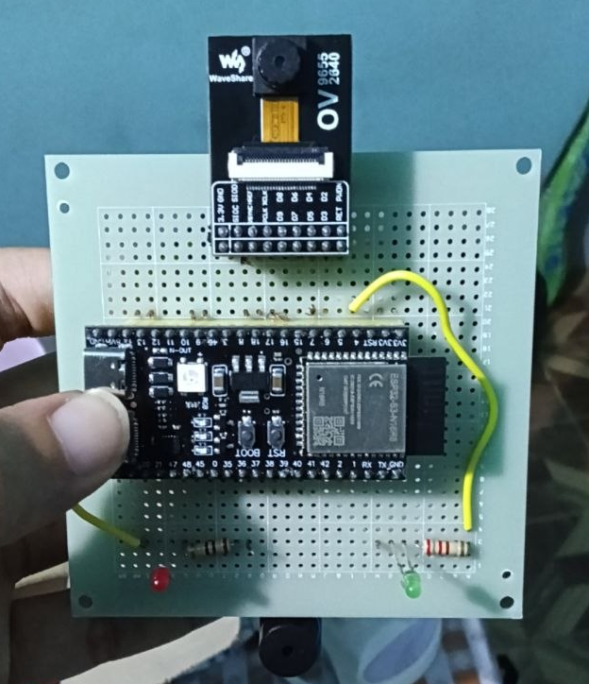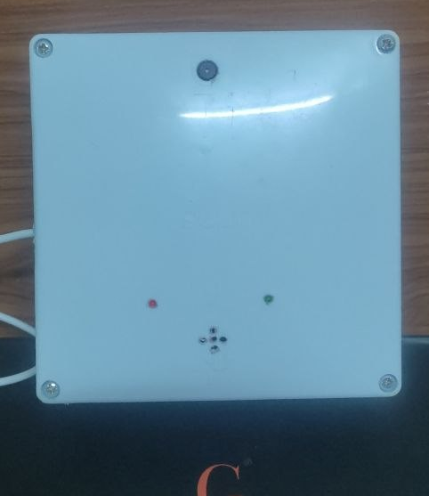
Figure 5.1 Hardware prototype assembly (left) and enclosed unit (right)

5.1.3. Hardware Communication and Local Feedback
During operation, the ESP32-S3 captures a JPEG image with the OV2640 and sends it over Wi-Fi to the attendance API using its device identifier and key. The backend selects the active session and eligible students, and the face service performs identification. The controller then reads the returned result and drives the green LED for successful verification or the red LED for a failed attempt, with buzzer feedback. The configured outputs use GPIO 4 for green, GPIO 5 for red, and GPIO 6 for the buzzer.
The prototype therefore provides feedback without requiring a student to view the web portal. A successful recognition and a newly created attendance record remain separate outcomes: a repeated verified scan can receive a successful identity result without adding another record. Reliable operation still depends on camera alignment, usable lighting, a stable supply, and network connectivity.
5.2. Functional and Verification Results
Automated verification was used to evaluate the main software behaviors. Existing backend Surefire reports contain 32 passing tests across authentication, academic management, CORS, dashboards, reporting, face-service integration, hardware attendance, notification delivery, and export formatting. The current Angular test run contains six passing tests covering the application shell and optimized authentication and navigation behavior. The Angular production build also completes successfully.
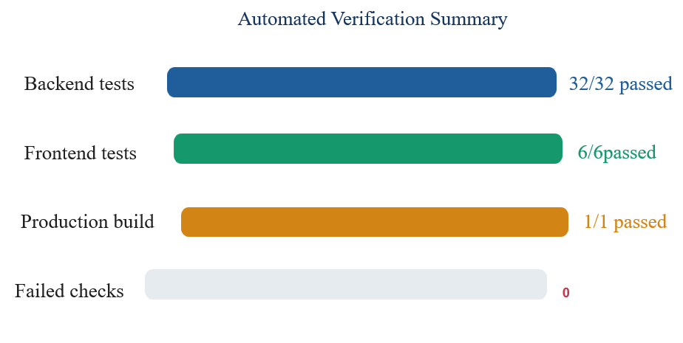
Figure 5.2 Automated verification results
Area | Verified result
Authentication | Login, access, refresh-token rotation, logout, replay protection, and role rejection
Academic management | Department, course, assignment, enrollment, timetable, and session consistency
Face attendance | Registration, verification, failed match, duplicate prevention, and FastAPI multipart contract
ESP32-S3 workflow | Managed device registration, secret protection, active-session discovery, identification, and duplicate response
Reports | Readable PDF and Excel output, weighted register, natural roll-number ordering, and dynamic cohort matrix
Responsive frontend | Role-aware pages, mobile attendance cards, loading and error states, and production compilation
Table 5.2 Summary of verified functional outcomes

5.2.1. Attendance Calculation Results
The weighted calculation was verified with four sessions and three roll calls per session. This produces 12 eligible roll calls. Attendance at three sessions contributes nine present roll calls and three absent roll calls, giving 9 / 12 x 100 = 75.00 percent. The JSON response, dashboard, PDF, and Excel register use the same totals.
Session date | Roll calls | Recorded state | Present units | Absent units
03/08 | 3 | Present | 3 | 0
10/08 | 3 | Present | 3 | 0
17/08 | 3 | Present | 3 | 0
24/08 | 3 | Absent | 0 | 3
Total | 12 | - | 9 | 3
Table 5.3 Verified weighted roll-call example
Overall student attendance is calculated across each student's enrolled courses. Tests cover cohorts with different course counts, ensure that non-enrolled course cells remain blank, and order roll numbers such as VMC-2 and VMC-11 naturally rather than lexicographically.

5.2.2. Attendance Decision Results
Condition | System result | Record created
Eligible face matched during active session | ATTENDANCE_VERIFIED | Yes
Same student scans again | ALREADY_VERIFIED | No
Face does not meet threshold | NOT_MATCHED | No
No single device-bound active session | Conflict response | No
Student is not an eligible candidate | Validation failure | No
Device identifier or secret is invalid | Authentication failure | No
Table 5.4 Attendance decision results

5.3. Smart Attendance Operating Modes
There are four modes namely ESP32-S3 Automatic Mode, Student Mobile Camera mode, Teacher and Administrator Management Mode and Report and Export Result.

5.3.1. ESP32-S3 Automatic Mode
In automatic classroom mode, the ESP32-S3 authenticates with its registered device identifier and secret. Its room or course binding resolves one active session. The OV2640 captures a face image and the firmware submits it for identification. The green and red LEDs and buzzer provide local feedback after the server response. Because academic values remain on the server, the same assembled device can continue operating after timetable changes.

5.3.2. Student Mobile Camera Mode
In mobile mode, an authenticated student opens an active session, captures an image, and submits it for verification. The backend derives the student from the JWT and checks enrollment, time window, face registration, and previous attendance. The interface provides permission, capture, verification, success, and retry states for phone use.
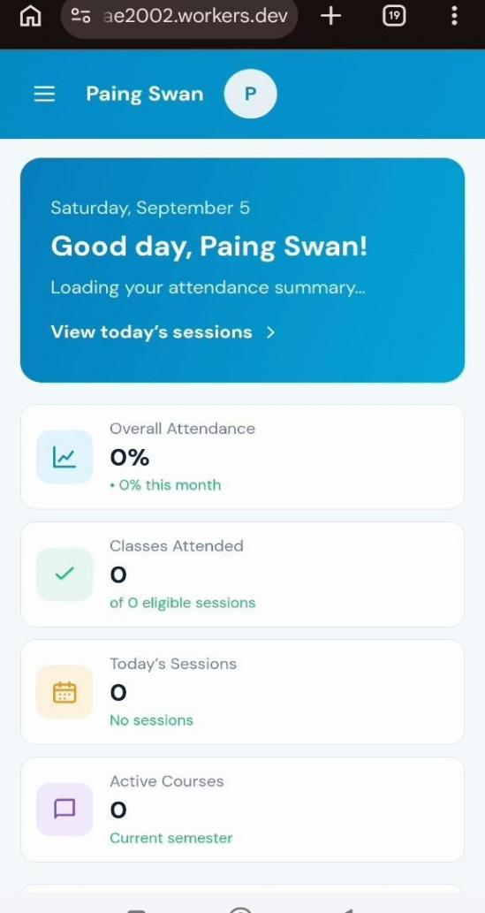
Dashboard
TEACHER REPORT
Overall Student Attendance
Fifth Year students - mobile card view
1
Honey Soe
VMC-1 - 5 courses
91.67
%
Present
55
Absent
5
Eligible
60
2
Paing Swan Pyae
VMC-11 - 5 courses
78.33
%
Present
47
Absent
13
Eligible
60
3
Zay Nyi Nyi Soe
VMC-14 - 4 courses
62.50
%
Present
30
Absent
18
Eligible
48

Figure 5.3. Responsive Teacher and Student Portal Layouts

5.3.3. Teacher and Administrator Management Mode
Teachers use course rosters, attendance sessions, records, study-year filtering, overall percentages, and Excel downloads. Administrators configure the academic structure, ESP32-S3 device binding, thresholds, audit records, and reports. Wide registers use table layouts on desktop, while mobile student rows use stacked cards so the attendance percentage remains visible.

5.3.4. Report and Export Results
The reporting module produces screen-oriented and print-oriented results. The course register follows the university attendance layout with one row per student, date and roll-call columns, present and absent totals, and a percentage. The teacher's overall workbook creates one percentage column per course, calculates each student's overall value with spreadsheet formulas, leaves non-enrolled course cells blank, and provides remark and signature areas.
No. | Roll No. | Student | IA-501 | MCE-52018 | Control | Overall | Remark
1 | VMC-1 | Honey Soe | 91.67% | 88.33% | 95.00% | 91.67% | Good
2 | VMC-2 | Hsue Ei Hlaing | 45.00% | 52.50% | - | 48.75% | Review
3 | VMC-11 | Paing Swan Pyae | 78.33% | 75.00% | 81.67% | 78.33% | Good
4 | VMC-14 | Zay Nyi Nyi Soe | 62.50% | 60.00% | - | 61.25% | Monitor
Table 5.5 Representative teacher cohort matrix layout
Exporter tests reopen generated files and verify structure, readable content, course columns, formulas, print layout, and natural ordering. Download operations are audited by the backend. The frontend sends the selected study year, period, reference date, and search filter to the complete, non-paginated Excel export.

5.4. Discussions
The results demonstrate that the project coordinates hardware, academic data, timetable rules, face recognition, attendance weighting, responsive presentation, and report generation through one consistent server-side model. Candidate-scoped identification reduces unnecessary comparisons, while uniqueness constraints and transaction boundaries protect against repeated scans and scheduler duplication.
The corrected hardware design separates the controller, camera, local feedback, assembly board, and enclosure into clear responsibilities. This makes the classroom unit easier to assemble and maintain than a design that assumes peripherals not present in the prototype. The junction box protects the electronics, while the LEDs and buzzer give users immediate feedback without requiring a browser screen.
The system still depends on stable network connectivity among the ESP32-S3, Spring Boot, and FastAPI. Recognition quality depends on lighting, camera position, image clarity, threshold calibration, and registered face data. The current recognition contract must not be treated as production-grade anti-spoofing until a genuine liveness model is validated. Hardware heartbeat monitoring, formal power testing, enclosure testing, and controlled performance measurement are also required before institution-wide deployment.
Recommended future work includes a trained liveness and anti-spoofing pipeline, an offline device queue with signed timestamps, hardware heartbeat and health history, controlled tests under documented lighting and participant conditions, expanded end-to-end tests, accessibility testing, centralized observability, and a tested disaster-recovery procedure.

5.5. Summary
The Smart Attendance System integrates the actual ESP32-S3 hardware unit with an OV2640 camera, buzzer, green and red LEDs, PCB board, and junction box, together with Angular, Spring Boot, PostgreSQL, and FastAPI. Verified software results cover authentication, academic management, automatic sessions, candidate-scoped identification, duplicate prevention, weighted attendance, responsive dashboards, and PDF and Excel reporting. Thirty-two backend tests and six frontend tests pass, and the production frontend build completes. Formal hardware and field-performance validation remains necessary before production deployment.

